Nama :Febri Aditiya

Nim :312010212

Kelas :TI.20.A2

Dosen :Wahyu Hadikristanto,S.Kom.,M.Kom

**“Ujian Tengah Semester”**

/*

* To change this license header, choose License Headers in Project Properties.

* To change this template file, choose Tools | Templates

* and open the template in the editor.

*/

package Biodata;

import java.util.Scanner ;

/**

*

* @author febri aditiya

*/

public class Biodata {

public static void main (String args [])

{

String nama = " " ;

String nim = " " ;

int nilai = 0 ;

Scanner masuk = new Scanner (System.in);

System.out.print("Nama : ");

nama = masuk.nextLine();

System.out.print("Nim : ");

nim = masuk.nextLine();

System.out.print("nilai :");

nilai = masuk.nextInt();

System.out.println("Nama : " + nama);

System.out.println("Nim : " + nim);

System.out.println("Nilai : " + nilai);

// proses if else

if (nilai >= 80 && nilai <=100){

System.out.println("A");

}else if (nilai >= 70 && nilai <=79){

System.out.println("B");

}else if (nilai >= 60 && nilai <=69){

System.out.println("C");

}else if (nilai >= 50 && nilai <=59){

System.out.println("D");

}else if (nilai >= 0 && nilai <=49){

System.out.println("E");

}

System.out.println("-----------------------");

System.out.println("-----------------------");

}

}

Output:

Nama : Febri Aditiya

Nim : 312010212

Nilai : 90

A

-----------------------

-----------------------

BUILD SUCCESSFUL (total time: 1 minute 46 seconds)

**\* Bila di kerjakan dari neatsbens nya maka akan seperti ini :**

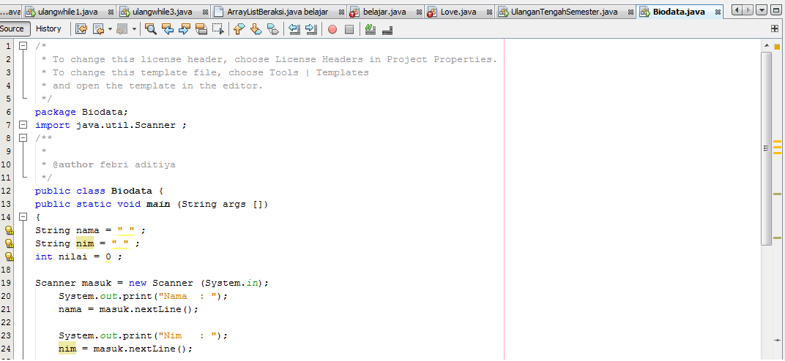

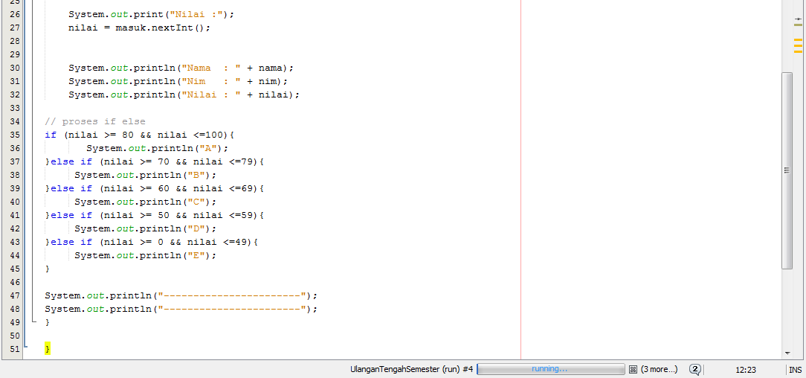

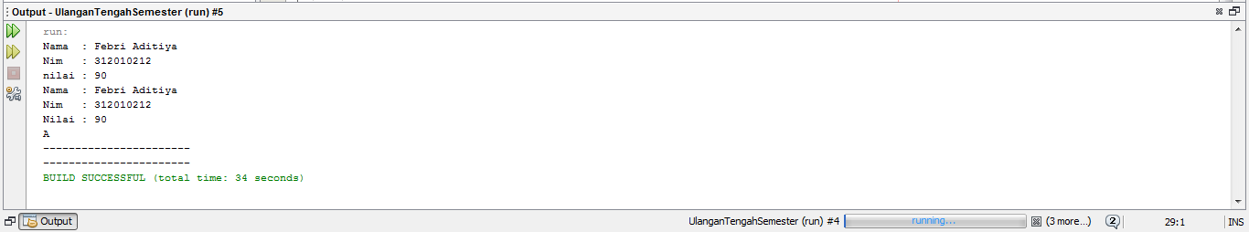

**\*Selesai**